Evolutionary Strategy

Optimization of Technology based on Ideas of Adaption and Evolution
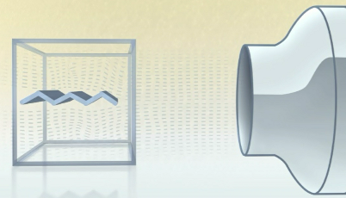
 Professor Ingo Rechenberg, PhD developed an optimization strategy at the Technical University of Berlin. He tried to imitate the principles of natural evolution, the so called “evolutionary strategy”.
Watch the film sequence “Artificial Evolution in Scientific Research” about Rechenberg’s experiment with the zigzag surface and the wind tunnel.
1. Why did Rechenberg do his experiment? Phrase the underlying question by completing the following sentence.
Rechenberg wanted to find out, _____________________________________________________
_________________________________________________________________________________
_________________________________________________________________________________
_________________________________________________________________________________

2. Each experiment has an independent variable, which is methodically changed between individual runs. Each test also has a dependent variable, which is measured each time. In addition, there are always a number of other parameters, which stay constant to see which influence the independent and dependent variable have on the experiment. Identify those aspects in Rechenberg’s zigzag plate experiment.
The independent variable in the zigzag plate experiment is ________________________________

_________________________________________________________________________________
The dependent variable in the zigzag plate experiment is __________________________________
_________________________________________________________________________________
Following variables have to be kept constant during the experiment, in order to determine the influence the independent variable has on the dependent variable: e.g.
_________________________________________________________________________________
_________________________________________________________________________________
_________________________________________________________________________________
3. Below is a screenshot from the last sequence of the film. Interpret the picture by linking it to the topic of “Evolution and Optimization” and try to explain what the creators of the film wanted to express through it.

















